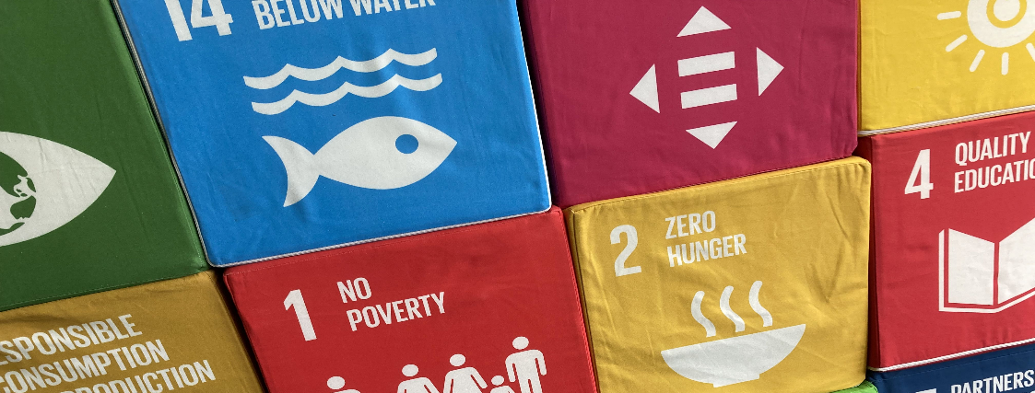
Formular „project idea“
Project
qualification N

Project team (and external partners if applicable)
Who is working on your project? Who is in charge of the project and is therefore the main contact person for the qualification N team? Do you work in cooperation with external partners?

Project manager
Name
Surname
E-mail
Study programme
Matriculation number
Start of qualification N (semester)

Team member 1
Name
Surname
E-mail
Study programme
Matriculation number
Start of qualification N (semester)
(add further team members if required)

External partners
Organisation
Name
Surname
E-mail
(add further partners if required)

When working with external partners: What role does the external partner play in your project? What is the division of labour? What agreements have been made regarding cooperation and the achievement of objectives?

[text]

Name of the project
What is the name of your project? What short and memorable name will arouse interest and create an association with the topic of the project? What creative word inventions, abbreviations, acronyms, etc. could be considered for your project?

[text]

Problem definition [approx. 2000 characters]
What problem do you want to help solve with your project? Who or what is affected by this problem? What are the causes of the problem? What (other) solutions to the problem already exist from other actors? Why did you decide on a project in this specific problem area?

[text]

Reference to sustainability [approx. 2000 characters]
How does your project relate to sustainability? To what extent is the project linked to one or more of the Sustainable Development Goals? What contribution can your project make to a socio-ecological transformation (of the university, the city, society, the economy, etc.)?

[text]

Project objectives
SMART OBJECTIVES
Specific: Describe your desired target state as precisely as possible and yet in a way that is easy to understand.
Measurable: Formulate criteria on the basis of which the achievement of objectives can be determined. These can be quantitative/hard criteria or qualitative/soft criteria.
Attractive: Formulate goals that motivate you to achieve and that are tailored to you as a group.
Realistic: Your goals should be ambitious, but achievable under the given circumstances (time, money, team, etc.).
Terminated: Formulate your goals with a concrete time horizon.
What do you want to achieve during the project? How many people do you want to reach with your programmes? What structures do you want to establish? What impact do you want to generate with your project?

Project objectives
1.
2.
3.
…
…
(insert further lines if required)

Measures and timetable [approx. 2000 characters]
What specific activities do you want to carry out to achieve your project goals? What individual measures are planned? What is your timetable?

[text]

Challenges and obstacles [approx. 1000 characters]
Where do you see the biggest challenges and obstacles for the successful realisation of your project? How are you trying to overcome these obstacles?

[text]

If you have any questions or need support, please contact Barbara Ette:

Barbara Ette
Coordinator for teaching in the area of sustainability
Staff Unit Sustainability
07531 88 4243
barbara.ette@uni-konstanz.de

