|  |  |
| --- | --- |
| UniKonstanz_Logo_Minimum_RGB-4 | General Laboratory Regulations |

These General Laboratory Regulations are issued to all laboratories at the University of Konstanz that conduct chemical, physical, microbiological or genetic testing, and carry out activities involving hazardous materials. Depending on the field of work, these regulations must be edited or expanded to cover specific, work-related conditions.

These Laboratory Regulations periodically are expanded in their scope by appendices addressing specific topics and rules, which are posted on the Internet as issued.

The safety regulations and rules of conduct apply without exception to all employees who work in a laboratory.

Department supervisors (department chairs, lab supervisors) are responsible for ensuring that new employees are informed of the content of these Laboratory Regulations, and that such persons, with their signature, acknowledge receipt of these Laboratory Regulations and agree to adhere to them.

These Laboratory Regulations do not claim to be exhaustive.

They supplement relevant state and professional rules and codes, such as Germany's Hazardous Substances Ordinance (Gefahrstoffverordnung), Biomaterials Regulations (Biostoffverordnung), Genetic Engineering Safety Regulations (Gentechnik-Sicherheitsverordnung), Laboratory Directive (GUV-R120), etc.

**Table of Contents**

[I. EMERGENCY INFORMATION (see Section VIII for additional notes.) 2](#_Toc214159662)

[II. GENERAL 2](#_Toc214159663)

[III. WORKING WITH HAZARDOUS MATERIALS 5](#_Toc214159664)

[IV. PERSONAL PROTECTIVE EQUIPMENT 8](#_Toc214159665)

[V. EQUIPMENT AND ELECTRICAL DEVICES 11](#_Toc214159666)

[VI. PROTECTIVE AND SAFETY EQUIPMENT AND FACILITIES 12](#_Toc214159667)

[VII. WASTE DISPOSAL 14](#_Toc214159668)

[VIII. ACTION IN THE EVENT OF A DANGEROUS SITUATION 15](#_Toc214159669)

I. EMERGENCY INFORMATION  
 (see Section VIII for additional notes.)

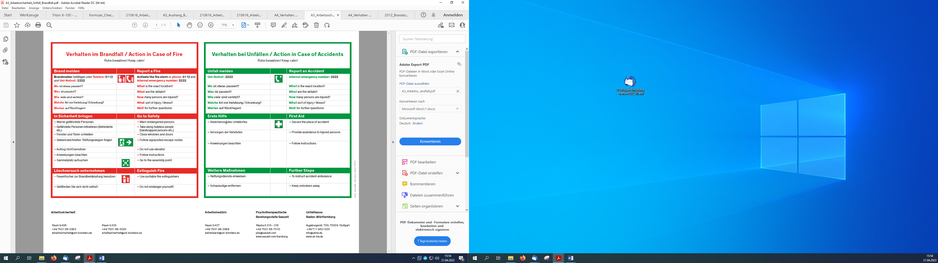

II. GENERAL

1. Working under a fume hood

1.1 All chemical work generally is to be conducted under a fume hood. This applies in particular to activities during which the release of hazardous substances cannot be ruled out entirely.

1.2 Before starting work, ensure that the **fume hood is switched on**. Periodically check the **operating display**, provided on all fume hoods, which indicates the exhaust air flow. Do not use fume hoods that are defective or periodically disconnected to save energy. If a device is defective, inform the I-Point. If a fume hood is not equipped with an automatic function for monitoring air flow, a simple substitute (paper strip, thread, etc.) should be mounted in user's field of vision. In this case, however, no conclusions can be drawn about the air volume; the makeshift monitor only signalizes that the fume hood is basically functional.

1.3 In the case of **fume hoods with two settings** (Setting 2 = Higher volume flow rate), always use the higher setting for experiments in which hazardous substances could be released, or when working with hazardous substances with a high vapor pressure.

1.4 The **sash on a fume hood** must be pulled down as far as possible. Open it only as far as needed to set up or operate apparatus. During experiments, only open the sash far enough to ensure that the face and neck are still protected by the panel.

1.5 Keep laboratory doors closed. Open doors impair the function of the hoods and the exhaust air flow.

2. Laboratory access

2.1. All laboratories are to be locked in the absence of laboratory staff. If this is impossible for reasons of university activities, e.g. the required safety cannot be ensured in teaching labs, a sign is to be posted on the doors that reads: "No Entry. Authorized personnel only. Visitors report to Room ….."

2.2 If **unfamiliar persons** are encountered in laboratories, ask them why they are there and request them to leave.

3. Hazardous tasksHazardous tasks include, for example, all work with highly toxic, toxic, extremely flammable, highly flammable and explosive hazardous substances, or work with a high danger potential (e.g. work with vacuum, pressure, Carius tubes, autoclaves, compressed gas cylinders, open flames, hot air blowers, hydrogenation processes, ozonolysis processes, etc.).

3.1 Always carry out hazardous tasks under safe conditions (under a fume hood, behind a safety screen, in special rooms, etc.).

3.2 Ensure that all persons in the vicinity are informed of any dangers and required safety measures.

3.3 Hazardous tasks **may** **not be performed alone**. During work of this kind, at least one other person must be within earshot.   
This rule is to be observed particularly for work outside the standard laboratory work hours.

4. Long-term experiments / Overnight experiments

4.1 If conducting experiments requiring **constant supervision**, you may only leave your post once another person trained in the task comes to replace you.

4.2 Long-term experiments without supervision must be labeled and conducted in such a way that, based on careful and professional judgment, any risk is ruled out, even outside standard work hours. The person responsible for the experiment must be reachable by telephone (he/she must post his/her telephone number on the outside of the laboratory door).

4.3 Chemical reactions that must be continued overnight for special reasons may only be conducted in the night rooms provided and secured for this purpose (e.g. with an automatic CO2 extinguishing system). All applicable safety procedures (some of which are posted on the doors or walls of the room) must be observed.

5. Endangering third parties (e.g. cleaning staff, maintenance staff)

5.1 **Maintenance and cleaning work**In order for external or university personnel to carry out necessary maintenance and cleaning work, laboratory staff must ensure that the affected areas of the laboratory are cleared of any chemicals and apparatus, and that cleaning and maintenance personnel can perform their tasks without risk (see also the rules and regulations for external companies on the Occupational Health and Safety department's website).

5.2 **Contaminated laboratory equipment  
Workpieces for the glassblower** must not contain any chemical residues. If items were rinsed with solvent, make sure the solvent has been removed entirely, if necessary by blowing out the item with nitrogen. Remember that a combustible atmosphere may exist in cavities inside the workpieces.

If **vacuum pumps, centrifuges, magnetic stirrers or other electrical laboratory devices** are handed in to the science equipment shops for maintenance or repair, check ahead of time to ensure that they are not contaminated with chemicals.  
When handing in vacuum pumps, a "Contamination Declaration" must be signed indicating the contaminants in the pump oil or stating that the pump is free of contaminants.

**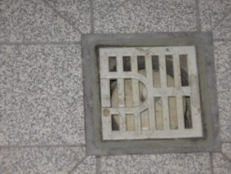**

1. **Odor emissions from drain traps**   
   Some laboratories are equipped with floor drains (traps), which are to be kept filled with water or glycerin at all times to seal off the waste water system from the low pressure prevailing in the laboratory. In addition, this limits disturbing odors.

7. **Defective building systems** (ventilation, heating, electric power, water, waste water, gas) are to be reported without delay to the I-Point (Tel. 2699).

8. **Walkways, passageways, doors and windows** (particularly the marked emergency exit windows) and **escape balconies** must be freely accessible at all times. Cables and hoses that cross over walkways must be installed under cable covers or in ducts.

III. WORKING WITH HAZARDOUS MATERIALS

Hazardous materials are gaseous, liquid, solid or powdery substances or preparations which are assigned to the hazard classes,

|  |  |  |  |  |
| --- | --- | --- | --- | --- |
|  |  |  |  |  |
|  |  |  |  |  |

which are classified as "flammable" (with no hazard symbol), "carcinogenic," "reproductive hazard," "teratogenic," "mutagenic," or "sensitizing," or which in any other way can cause chronic health damage. Hazardous materials also include any dangerous substances released during laboratory work.

In accordance with the German Hazardous Substances Ordinance (Gefahrstoffverordnung), hazardous materials further include substances that are not labeled, or that do not display any of the hazardous attributes mentioned above, such as:  
⬩ Gases with a narcotic effect   
⬩ Gases with a suffocating effect, such as nitrogen, carbon dioxide and extinguishing gases

⬩ Gases liquefied at very low temperatures and dry ice   
⬩ Hot substances, such as liquefied metals and steam   
⬩ Pre-sensitizing substances, such as water for wet work or skin-defatting solvents

"Working with hazardous materials" includes the production and use of hazardous materials (consumption, storage, processing, filling, transfer from one container to another, mixing, removal, destruction and transport within the university).

**Attention:** Change of hazard symbols

Since January 20, 2009, the Globally Harmonised System of Classification and Labelling of Chemicals (GHS) for the labelling and packaging of substances and mixtures has been in force (in the EU CLP Regulation (Regulation of Classification, Labelling and Packaging).  
This governs the classification and labelling of hazardous substances used and is associated with the following changes to the existing labelling system:

* The current labelling / hazard symbols will be replaced with new hazard pictograms and supplemented by a signal word
* The risk statements "R statements" are replaced by H statements (hazard statement)
* The safety statements "S statements" are replaced by P statements "(precautionary statement)

This new labelling is currently mandatory only for pure substances. For mixtures, there is a transitional period until June 1, 2015.

Products can thus be characterized with old or new labelling.

For more information, visit the websites of Occupational Safety under the heading "hazardous materials / biomaterials".

An e-learning module "GHS - CLP - The new labelling" is also available.

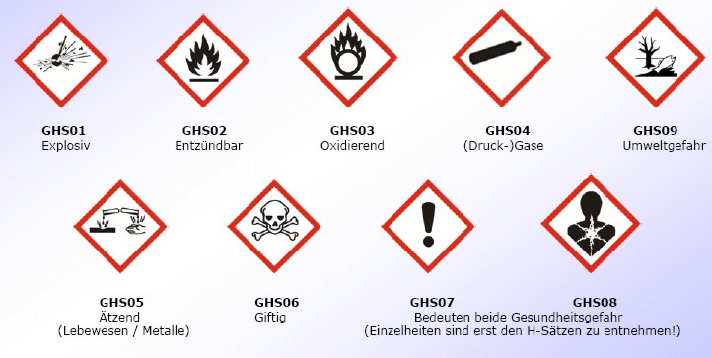

Both mean hazardous to health  
 (details are found in the H statements!)

Poisonous

Corrosive   
 (creatures /metals)

Environmentally   
 hazardous

(Compressed)   
 gases

Flammable

Oxidizing

Flammable

Explosive

(GHS hazard pictograms with signal word and H and P statements)

1. **Information sources**  
Before starting work, the risks associated with the hazardous materials used or released must be determined.The following can serve as information sources:

⮚ Codes on the label (hazard symbol, R and S phrases)

⮚ Research in the DAMARIS Dangerous Materials Registry Information System

⮚ Reference works. Loose-leaf collections (e.g. Kühn/Birett "Gefährliche  
 Arbeitsstoffe," Roth/Weller "Gefährliche chemische Reaktionen")

⮚ Safety Data Sheets

⮚ Standard Operating Procedures

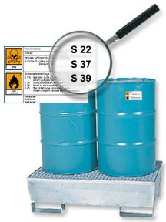2. **Standard Operating Procedures**  
Standard Operating Procedures (SOPs) must be available for hazardous materials and special equipment (e.g. autoclaves, centrifuges, etc.).  
As a service, the Occupational Health and Safety department has posted numerous Standard Operating Procedures for hazardous materials, laboratory apparatus, etc. on its website (<http://www.uni-konstanz.de/ZE/Rektorat/AS/betranw.shtml>) and can provide assistance if necessary in drawing up new SOPs.  
The sample SOPs must be modified or expanded in order to reflect conditions and situations specific to a job or task. They also serve as instructional aids for supervisors.

3. **Labeling**

3.1 Containers must be labeled in accordance with their contents: common name of the substance written out in full, possibly the constituents, hazard symbols with hazard description, R and S phrases. Labeling with R and S phrases is not necessary in the case of bottles containing hazardous substances in small quantities intended for daily use.

3.2 Pipes (e.g. permanently installed gas lines) and containers also must be labeled: substance name, hazard symbol and hazard description.

4. **Storage**

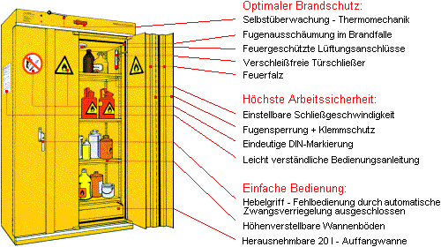

4.1 Hazardous substances may only be stored in the laboratories in the quantities required for current work. They may only be stored in the safety cabinets provided for this purpose.

* 1. 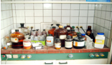Only the equipment and chemicals needed to perform a current   
     task may be kept inside fume hoods.  
     **Fume hoods are not to be used for storage!**

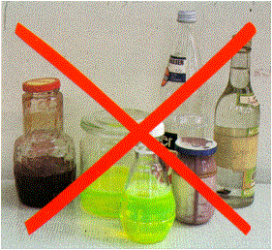4.3 Do not put or store hazardous substances in containers that could be mistaken for food (drink bottles, jelly jars, etc.). Do not store food together with hazardous substances.

4.4 Substances that could cause a dangerous reaction if they were to come into contact with one another due to a leaky container or release into the air may not be stored in the direct vicinity of one another. Contact can be prevented by placing the containers in separate catch basins.

4.5 Chemicals that can evolve harmful, environmentally hazardous or combustible gases are to be stored in tightly sealed containers.  
The ground joints of laboratory vessels are to be secured if the vessels contain substances that develop a noticeable vapor pressure even at room temperature. The vessels must be made of suitable materials. Plastics in particular frequently are not sufficiently resistant. Due care must also be given to selecting the bottle closures.

4.6 **Highly toxic and toxic substances** are to be kept under lock and key (e.g. in a locked cabinet for toxic materials) and accessible only to persons trained in their use.

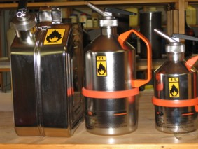

4.7 **Combustible liquids** may only be present in a laboratory in quantities required for a day's use, and stored only in containers with a maximum capacity of 1 liter. If the daily requirement is higher, it is also permissible to use glass containers with a capacity of 2.5 liters, metal containers with a maximum capacity of 10 liters or plastic containers with a maximum capacity of 5 liters. Stainless steel safety containers, available in the chemicals store, are practical for this purpose.

After use, solvents are to be stored either in safety cabinets or in the storerooms provided for this purpose. They may not be stored in the fume hoods.

4.8 Combustible liquids, as well as extremely or highly flammable hazardous materials may only be stored in **refrigerators or freezer chests** if no ignition sources exist on the inside (ignition sources include: lamps, light switches, temperature controls, automatic defrost controls).  
Standard refrigerators and freezer chests must be modified by the Electrical Equipment department and provided with a sign that reads: "Only free of ignition sources inside."  
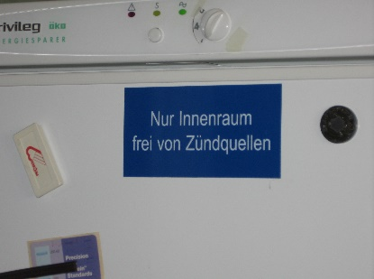 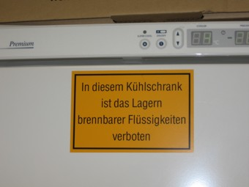

Refrigerators whose interior is not free of ignition sources must bear a sign that reads: "No combustible liquids are to be stored in this refrigerator."  
The signs are available from the Electrical Equipment department.

4.9 The supply of **gas cylinders and spray cans** containing extremely flammable propane/butane as the propellant is to be limited to the daily requirement. Larger quantities are to be stored in the storerooms or safety cabinets for compressed gas cylinders; spray cans also can be stored in the storerooms or safety cabinets for combustible liquids.

4.10 When using liquefied gas (propane, butane) as burner fuel, a maximum of 1 liquefied gas cylinder with a maximum fill weight of 14 kg may be present in a laboratory at any given time. Spare cylinders are not permitted in the laboratory. The cylinder must be kept in a protected place (e.g. gas cylinder cabinet). Safety zones free of any ignition sources must be provided around the site where the cylinder is installed.

5. **Hygiene measures**

5.1 Work areas and fume hoods must be kept clean at all times.

5.2 Never pipette hazardous substances by mouth.

5.3 Keep chemical containers clean on the outside so they can be handled without risk.

5.4 Clean contaminated apparatus and work surfaces immediately. Set up work surfaces such that they can be cleaned at any time.

5.5 Any hazardous substances that spill, e.g. onto the floor, must be cleaned up immediately by the person involved; this task is not to be left to cleaning staff.



5.6 No eating, drinking, using snuff tobacco or smoking is permitted in the laboratory. This rule is intended to prevent the unintentional intake of hazardous substances via contaminated food, or via products of decomposition that form at the tip of a burning cigarette.

6. **Transport**

6.1 When transporting breakable containers of hazardous substances, use buckets or other transport aids that can safely hold the entire volume should the container break. Do not carry **glass bottles** by the neck.

6.2 **Compressed gas cylinders** may only be transported on cylinder carts and only with the protective cap screwed on.

6.3 **Cryogenic liquefied gases** (e.g. liquid nitrogen and helium) may only be transported in the service elevator. Ensure that no other persons ride the elevator or enter at another floor.

IV. PERSONAL PROTECTIVE EQUIPMENT

The required protective equipment must be worn when performing dangerous tasks.

1. **Protective clothing**

1.1 In the laboratory, wear a protective laboratory coat (sufficiently long with long sleeves) made of a material that does not increase the risk in the event of a fire owing to its burning and melting behavior. Suitable materials include cotton or blends (cotton/polyester) with ≥ 35% cotton.

1.2 Immediately take off lab coats contaminated with chemicals. An adequate number of spare lab coats are to be kept in stock. Wear lab coats only in the laboratory. Take them off before going to lecture halls, offices or the library.

1.3 Hang clothing not worn in the laboratory (e.g. coats) in the coat closet when working. It is strongly recommended that lab personnel keep a complete set of spare clothes in the coat closet so that clothing contaminated with chemicals can be changed immediately.

1.4 Wear only sturdy shoes with good traction.

2**. Protective eyewear**

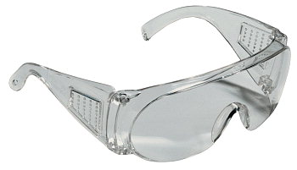2.1 All persons in a laboratory must wear safety glasses with sufficient side guards at all times. The eyes are at risk of injury, for example, when handling hazardous substances (also when other persons in the laboratory are using them), when working with a vacuum or high pressure, when lab apparatus breaks or debris flies through the air.

* 1. Prescription eyeglass-wearers must either put on safety eyewear that fits over their glasses or have suitable safety glasses with corrective lenses made for them.
  2. Safety glasses (with or without corrective lenses) can be obtained from the Eyewear Officer (Mr. Straub L1103, Tel. 3000). To have safety glasses with corrective lenses made, you must submit up-to-date information on your prescription eyeglasses.

**3. Protective gloves**



3.1 On account of their very thin wall thickness, the gloves commonly used in everyday laboratory practice (latex or nitrile disposable gloves) primarily protect against splashes. If they come into contact with chemicals, the penetration time often is only a few minutes. Gloves therefore should be changed frequently.

3.2 Gardening or household gloves are not suitable for laboratory use.

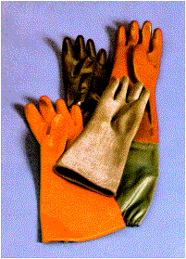

3.3 If skin contact cannot be ruled out, wear suitable protective gloves when working with hazardous substances that display, for example, corrosive, skin-irritating, sensitizing or skin-defatting (solvents) properties. The gloves must be sufficiently resistant to chemicals (consult manufacturer product catalogs for information on resistance) and comply with European safety standards ("CE" label, pictogram, performance indices and instructions for use on the package).   
Information on suitable protective glove materials also is available in the "Information Sheet: Protective Gloves," posted on the Occupational Health and Safety department's website.

3.4 Immediately remove disposable gloves if they come into contact with chemicals, because the gloves have a very short penetration time.

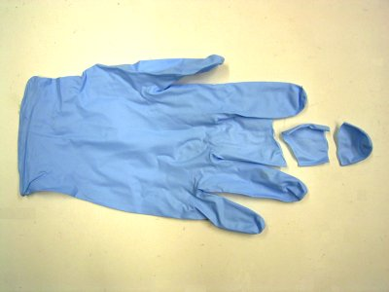 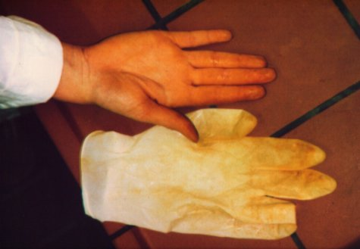

3.5 Dispose of protective gloves with limited chemical resistance in good time. Thoroughly dry sweaty gloves after use.

3.6 When wearing protective gloves, do not touch any objects that do not come into contact with chemicals by nature of their function (e.g. door handles, books, laboratory logs, etc.).

4. **Respiratory protection**



* 1. Suitable respiratory protective devices must be at hand if dangerous concentrations of hazardous substances can become airborne (during experiments or in the event of an accident).
  2. It is not necessary to wear respiratory protective equipment continuously.
  3. 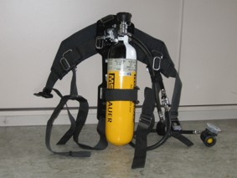When handling toxic gases (e.g. chlorine, carbon monoxide), emergency masks must be carried or kept ready for use in a safe place near the work area (e.g. hall cabinet).
  4. The emergency air-supplying respirators stored in the vicinity of the elevators on L6 and P6 are only for persons trained in their use.

V. EQUIPMENT AND ELECTRICAL DEVICES

Equipment may only be used for the purpose for which it was intended.  
All persons working in a laboratory are obligated to familiarize themselves with the proper use of the various types of equipment before commencing work (operating instructions).

1. **Damaged apparatus and defective electrical devices**

Defective equipment (e.g. defective or burned cables, plugs with corroded contacts, heating mantles with damaged heating elements) must be taken out of service immediately and turned in for repair.

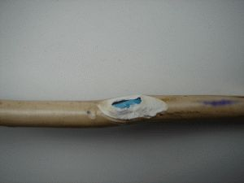 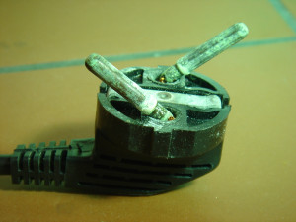 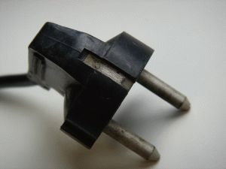 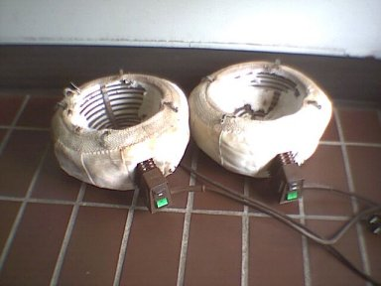

2. **Use of pumps**   
Gases extracted by pumps must be conducted via the fume hoods to the exhaust air duct. Oil pumps must be equipped with an oil mist filter.

3. Operate **autoclaves, rotary evaporators, other pressure and vacuum apparatus, centrifuges, etc.** with particular care and only after thorough instruction. Also observe the SOPs for a device. Store them and the operating instructions together with the device in a place that is easily accessible to all staff.

4. **Modifying/repairing electrical laboratory devices**   
Work of this kind may only be performed by trained electricians. For more information on regulations, see the "Safety Information for Working **On and With** Electrical Systems and Devices" (Sicherheitshinweisen zu Arbeiten **an und mit** Elektrischen Anlagen und Betriebsmitteln), posted on the Occupational Health and Safety department's website.  
http://www.uni-konstanz.de/ZE/Rektorat/AS/pruefpflichtige\_einrichtungen.shtml

5. **Prohibited use**  
Use of the following electrical devices is prohibited in all rooms:

* Immersion water heaters, water baths without a dry-running protection function
* Hot air blowers (dryers) without overheating protection or insufficiently shielded heating coils.

**Coffee machines, water boilers**, etc. may not be operated in the laboratory.

6. **Devices that run hot**   
Devices that exhaust hot air via ventilation grilles or slits (e.g. monitors) must be positioned such that the ventilation openings are unobstructed and the necessary air circulation is not impeded in any way. In particular, do not lay paper on the ventilation openings!

7. **Switch off** laboratory devices **after finishing work**. On devices operated under a fume hood, also pull the plug. Exceptions to this rule include devices operated in the night laboratories and equipment designed for continuous operation (e.g. refrigerators).

8. **Heating devices** (e.g. drying cupboard, magnetic stirrers, heating baths) may only be operated without supervision if they have an emergency off function should the temperature control fail, or if it is impossible for the target temperature to be exceeded due to the device's low heating capacity.

VI. PROTECTIVE AND SAFETY EQUIPMENT AND FACILITIES

1. All laboratory staff must be instructed regarding the location and function of the following safety equipment and facilities closest to their work area.

| **Safety equipment/facility** | **Marking** |
| --- | --- |
| Escape routes (primary and secondary escape routes) and emergency exits |  |
| Assembly point |  |
| Emergency telephones |  |
| Emergency gas switches and shut-off valves for gas lines in the laboratory and in the corridor leading to the laboratory. | Gasnotschalter0349 |
| Main switch (e.g. emergency shutdown) for the electrical supply inside the laboratory. | Notaus0356 |
| Emergency showers (eye wash stations and body showers) |  |
| Fire alarms (push-button alarms) | Feuermelder2 |
| Automatic fire alarms, alarms inside false ceilings (red sign only) | Brandmelder1 Brandmelder2 |
| Fire extinguishers |  |
| Fire blankets and sand containers |  |
| First-aid materials (first-aid kit) |  |
| Chemical binders (absorbent medium, mercury binder) | Chemikalienbinder0354 |
| Respiratory protective equipment |  |

2. All protective and safety equipment and facilities must be kept functional, clearly visible and easily accessible at all times (do not hang or otherwise attach objects to this equipment).

3. Affix a clearly visible sticker with the emergency telephone number (2222) to every telephone or in the direct vicinity thereof.

4. Refill **containers for chemical binders** or sand (for extinguishing fires) after every use. To do so, contact the Occupational Health and Safety department or, in the case of sand, the building superintendent.

5. Replace **used fire extinguishers**, or those with a broken lead seal, with new ones at the chemicals store.

6. **Walkways, escape and rescue routes**, as well as **escape balconies**, must be kept clear at all times. They are not alternative work or storage areas. Do not deposit clothing, bags, etc. in the corridors in front of a laboratory. They belong in the lockers. In addition, ensure that windows marked as "Emergency Exits" are not blocked off. Chairs may only be placed in front of desks at the windows.

7. **Superfluous fire loads** in the laboratory and corridors are to be removed. Packaging material made of polystyrene is a particular risk, because it leads to extreme smoke generation in the event of a fire.

8. Report any obvious defects in safety equipment to your supervisor immediately.

VII. WASTE DISPOSAL

1. **Never** dispose of hazardous substances in the **waste water**.
2. **Reactive residues / waste chemicals**, e.g. alkaline metals, peroxides, hydrides, Raney nickel catalysts, are to be converted to less hazardous substances by the appropriate methods (cf. Appendix 5 Waste Elimination/Deactivating reactive or strongly odorous hazardous substances (Abfallvernichtung / Desaktivierung reaktiver oder stark geruchsbelästigender Gefahrstoffe)).
3. **Solvent waste**
   1. Solvent waste is to be collected in the separate containers for **non-halogens** or **halogens** provided by the hazardous wastes store.
   2. 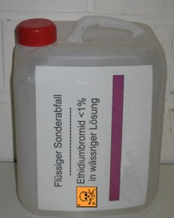Before disposing of solvents, filter out any solids they contain.
   3. Two-phase solvent wastes are to be separated in a separating funnel before disposal.
   4. Do not use any containers made of aluminum or stainless steel (risk of leaks due to corrosion, if the solvents contain acids).
4. **Labeling**In accordance with the German Hazardous Substances Ordinance, waste containers are to be labeled with the substance name, if necessary its constituents, and the hazard symbols appropriate for the substance's or mixture's properties.
5. **Storage**   
   In the laboratory, hazardous wastes are to be stored under the same safety conditions (e.g. solvent wastes in the safety cabinet) as all other hazardous substances.  
   Storing waste canisters in wash basins or fume hoods in prohibited.
6. **Broken glass and other sharp objects** are to be collected in puncture-proof, rigid containers.
7. **Spilled mercury** is to be taken up using a suitable absorbent medium (e.g. Mercurisorb) and handed in to the hazardous wastes store in a closed container.
8. **Glass waste**  
   Empty chemical bottles and glass apparatus must be cleaned before handing in for disposal. They should contain no chemical residues.
9. **Plastic waste**  
   Do not dispose of containers and objects contaminated with hazardous substances in the general waste containers in the unpacking room. They are to be handed in to the hazardous wastes store.
10. **Devices**Consult the staff at the hazardous wastes store before disposing of contaminated devices or devices containing harmful substances (e.g. asbestos, mercury).

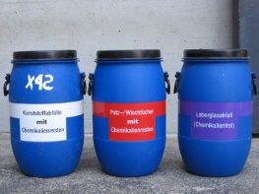

1. **Cleaning cloths, wipes, disposable gloves**  
   1. Collect and hand in contaminated cleaning cloths, wipes and disposable gloves in a suitable container.
   2. 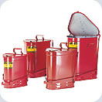If they are contaminated with self-igniting or flammable substances (e.g. combustible solvents), they must be collected in special waste containers (to prevent fires). In this case, do not use containers made of plastic.
2. **Solids**  
   Collect and hand in filter and absorbent media in a suitable container.
3. **Opening hours of the wastes store / supervisors**  
   Wastes are to be handed in only during opening hours or after consulting the staff of the hazardous wastes store.  
   Waste can be handed in on the courtyard of the chemistry building, on the ramp to the hazardous wastes store.  
     
   Opening hours: Tuesday and Friday 1:15 p.m. – 2:15 p.m.
4. **Declaration for chemical waste**   
   To hand in chemical waste, you must fill out a declaration as required by the hazardous wastes store.

VIII. ACTION IN THE EVENT OF A DANGEROUS SITUATION

If a dangerous situation arises (e.g. gases or vapors are released into the air, hazardous liquids leak, fire breaks out), remember first to:  
  
**⮚ STAY CALM  
⮚ ENSURE YOUR OWN SAFETY BEFORE PROVIDING ASSISTANCE   
⮚ CALL THE EMERGENCY NUMBER (2222) AS SOON AS POSSIBLE**

1. **What to do if hazardous substances escape**

Depending on the level of danger, take the following precautions:

- Stop work and safely end current experiments

- Ensure your own safety

- Limit contamination (e.g. by shutting windows and doors)

- Clear the affected work area

- Inform your supervisor, safety personnel in the Occupational Health and Safety department, and the Chemistry department's health and safety officers (Dr. Röll, Dr. Sulger, Mr. Kirsten)

- Announce that no one is permitted to enter the room and post a message on the door

- Danger zones are only to be accessed by persons expressly authorized to do so

- Have repair or cleanup work performed by trained personnel

- All work in danger zones is to be performed only with suitable and adequate personal protective equipment

- Inspect repair or cleanup work before resuming work in the rooms or work areas

- Dispose of spilled chemicals at the hazardous wastes store

**Combustible gases escaping uncontrollably** are extremely dangerous, therefore:

- Shut off the gas supply (if you can do so without endangering yourself)

- Air out the room or work area; use respiratory protection

- Keep away any sources of ignition; avoid sparks

- Shut off the power supply outside the danger zone

- Inform your supervisor, the I-Point, safety personnel in the Occupational Health and Safety department, and the Chemistry department's health and safety officers (Dr. Röll, Dr. Sulger, Mr. Kirsten)

- Prevent access to the danger zone for any unauthorized persons

2. **What to do in the event of a fire**

- Stay calm; avoid rash, hasty action!

- Immediately fight incipient fires using fire extinguishers. Ensure sufficient distance from the fire, because the extinguisher jet otherwise can disperse burning liquids.

- Do not use water to extinguish a fire!

- Using several fire extinguishers simultaneously is more effective than using them consecutively.

- Keep in mind that some chemicals (e.g. metals like sodium, potassium, magnesium) require special extinguishing agents.

- Extinguished fires must be monitored continuously until they have cooled due to the risk of re-ignition.

- If you cannot extinguish a fire yourself, immediately activate the nearest manually operated fire alarm and call the I-Point.

- Shut down endangered experiments, gas, power and possibly also water supplies. If a risk of explosion exists, shut off the power supply outside the danger zone.

- Warn endangered persons; if necessary tell them to evacuate the premises.

- Secure the site of the accident.

- Close all doors (but do not lock them!); keep windows closed.

- Remove dangerous materials (e.g. compressed gas cylinders) from the danger zone, insofar as you can do so without putting yourself in danger.

- If rooms or corridors are full of smoke, crawl along the floor to escape. If the corridors are full of smoke, also open the smoke vents. Some rooms not equipped with continuous venting have a smoke extractor that can be activated in the corridor.

3. Report all accidents and significant damage to your departmental supervisor and the Occupational Health and Safety department. In the event of accidents causing injury, an accident report must also be made immediately.

4. **Alarms and announcements over the PA system**

4.1 **Building evacuation**If an announcement is made over the PA system requesting all persons to evacuate the building, use the escape routes to go immediately to your assigned assembly point. A headcount will be performed there to make sure everyone is accounted for.

* 1. In the event of an evacuation order, all departmental supervisors are responsible for checking whether all staff members in their area of responsibility have left the building.  
     Close the doors, but do not lock them.

5. **First-aid measures for injured persons (e.g. contact with hazardous substances)**The following measures should be taken until the emergency medical technicians arrive. Follow any first-aid instructions provided in substance-specific standard operating procedures.

Eyes:  
Go to the nearest eye wash station and, while protecting the uninjured eye, immediately rinse the eye with plenty of water while holding open the eyelids.

Respiratory organs:

Evacuate injured persons from the danger zone and provide fresh air.

Skin:

Rinse injured areas of the skin with plenty of water (e.g. emergency shower). Remove contaminated clothing.

Swallowing:

Thoroughly rinse the mouth and throat. Drink plenty of water in small sips.

Burns and scalding:

Immediately remove any clothing soaked with hot substances. Immediately immerse affected body parts in cold water or rinse under cold running water until pain subsides.