ERUA Early Career Researchers Workshop “Exploring Pathways Beyond Academia”
The "European Reform University Alliance" (ERUA) event series for Early Career Researchers closes with a workshop providing insights and guidance on how to pursue successful non-academic careers after completing your doctoral studies.
The workshop takes place at Université de Paris 8 on 24 and 25 October 2023.
The goal of the workshop is to empower early career researchers in Social Sciences and Humanities and Arts disciplines to make informed decisions about their career trajectories. By learning from experienced professionals and participating in practical workshops, participants will be better equipped to embark on successful non-academic journeys and contribute their expertise to various sectors beyond academia.
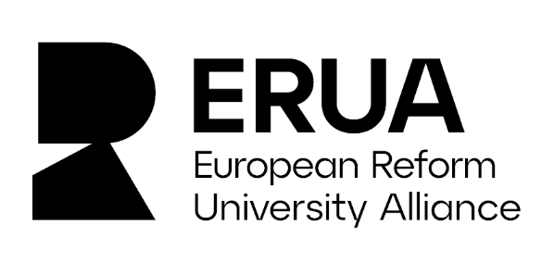
More details on the workshop are available in the official call for participation. If you are interested in participating, contact the ERUA team erua@uni-konstanz.de (Subject line: Workshop Pathways Beyond Academia). Application deadline is 30 September 2023.
An overview of the broad range of topics covered in the event series is available on the ERUA Early Career Researchers website. The other workshops of the series took place between 2022 and 2023, covering a broad scope of topics ranging from the way networking works and funding opportunities for collaborative research to specific scientific areas in which the ERUA partners have common portfolios.
Contact: Ramona Baumgartner, ERUA Management Team

