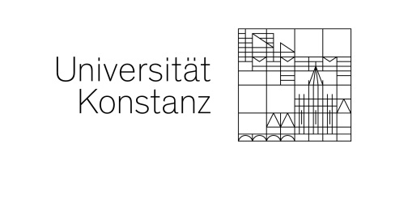
Data protection information for newsletters as per Article 13 GDPR

- Name and contact details of the data protection officer
The university’s data protection officer is:
Heinz-Joachim Sommer
Datenschutz-Sommer
Sommertalweg 1
88709 Meersburg, GERMANY
Email: datenschutzbeauftragter@uni-konstanz.de
Website: https://www.uni-konstanz.de/en/data-protection/

- Name and address of the responsible institution
The responsible institution as per the General Data Protection Regulation (GDPR), other national data protection laws of the member states as well as additional data protection regulations is the:
University of Konstanz
represented by its rector, Professor Kerstin Krieglstein
Universitaetsstrasse 10
78464 Konstanz
GERMANY
Phone: +49 7531 88-0
Email: onlineredaktion@uni-konstanz.de
Responsible for content:
Name or division/department, phone number
Email: address for reaching the person/university unit listed above

- Description and scope of data processing
When you subscribe to one of the University of Konstanz’s newsletters, the data you enter in the registration form will be transmitted to the phpList newsletter system.

The following data will be collected when you complete the registration form:
- The IP address of the accessing computer. This data will, however, immediately be replaced by a generic local placeholder-address of the server.
- The date and time of registration
- The email address you entered
- Information about when you received the newsletter, e.g. the issue dated XX.XX.2020
- Any changes, e.g. if you cancel your subscription
The data processed in the context of sending the newsletter will not be shared with third parties. The data will only be used to send the newsletter.
- Legal basis for processing personal data
The legal basis for processing the user’s personal data after subscribing to the newsletter is Art. 6 para. 1 lit. a of the GDPR.
- Reasons for data processing
The data collected are only used to send the newsletter.
- Storage duration
The data mentioned above will be stored as long as it is required for sending the newsletter. If you are no longer subscribed to one of the University of Konstanz’s newsletters, then all the corresponding data will be deleted from the newsletter system.
- Cancelling a newsletter subscription, withdrawal of consent
Subscriptions may be cancelled at any time. There is a corresponding “unsubscribe” link at the bottom of each newsletter in the area with a grey background. The processing of personal data is lawful until consent is withdrawn.
You cannot, however, unsubscribe to newsletters that the University of Konstanz uses to fulfil legal information requirements to its employees and students.
- Other rights
- In accordance with Article 15 GDPR, you have the right to request information from the University of Konstanz about any data it stores related to your person and/or to have incorrect data corrected as per Article 16 GDPR.
- You also have the right to demand that your data be deleted (Article 17 GDPR) or that the processing and use thereof be restricted (Article 18 GDPR).
- To better understand and exercise your rights, please contact our data protection officer by emailing datenschutzbeauftragter@uni-konstanz.de.
- You also have the right to file a complaint with the regulating authority if you believe that the processing and use of your personal data is in violation of the law (Art. 77 GDPR). The responsible contact person at the regulating authority is the “Landesbeauftragter für den Datenschutz und die Informationsfreiheit Baden-Württemberg” (state commissioner for data protection and the freedom of information in Baden-Württemberg) (https://www.baden-wuerttemberg.datenschutz.de).

