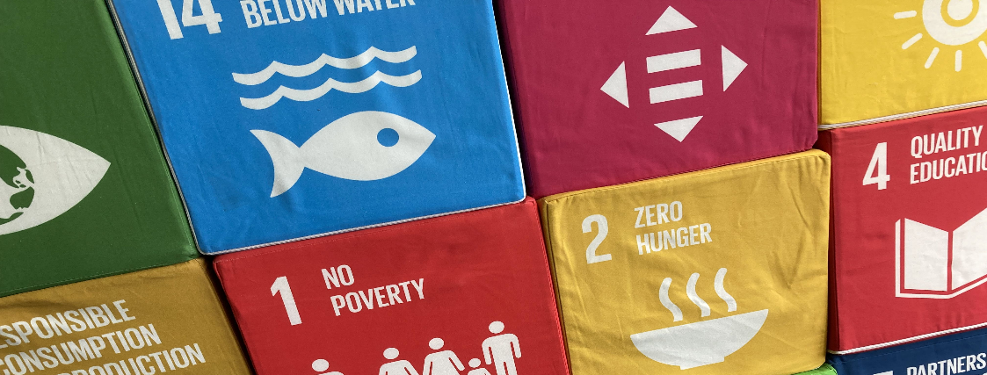
PROJECT REPORT
Project
qualification N

Name of the project

[text]

Project team (and external partners if applicable)
Who worked on your project? Did you realise your project with external partners? Who else was involved?

Team member 1
Surname
First name
E-Mail
Study programme
Matriculation number
Start of qualification N (semester)

Team member 2
Surname
First name
E-Mail
Study programme
Matriculation number
Start of qualification N (semester)
(add further team members if required)

External partner
Organisation
Surname
First name
E-Mail
(add further partners if required)

Confirmation external partner

I hereby confirm _____________________ (surname, first name of partner),
that __________________________ (surname, first name student) has realised the project named here in cooperation with our organisation/initiative/association/etc. in the period from _________ to ________.

____________________________ _______________________________
Place, date Signature

When working with external partners: What role did the external partner play in your project? What was the division of labour? What agreements were made regarding the collaboration and the achievement of objectives? How did the collaboration go?

[text]

Course of the project [approx. 2000 characters]
How did your project go? Which measures did you realise? What was the timeline? What did you do and realise?

[text]

Target achievement and sustainability impact [approx. 1000 characters]
Which (of the set) goals have you achieved with your project? How many people did you reach with your programme? Were you able to establish structures? What (sustainability) impact did your project generate? What contribution has your project made to sustainable transformation?

[text]

Challenges and obstacles [approx. 1000 characters]
What were the biggest challenges in realising your project? Were there any obstacles and hurdles in achieving the project goals? How did you deal with them? What solutions were found?

[text]

Reflection and lessons learned [approx. 3000 characters]
What insights did you gain from the planning and realisation of your project? Were there any "aha" moments? What did you take away from the project? What did you learn from the project? What tips would you give other qualifikation N participants for the project phase? What else would you have needed for the planning/realisation of your project?

[text]

Photo documentation
In addition to this short report, please send us 3-5 high-quality photos showing the realisation of your project. If people are depicted, please obtain a written declaration of consent. We will be happy to provide you with a form for this purpose.

If you have any questions or need support, please contact Barbara Ette:

Barbara Ette
Coordinator for teaching in the area of sustainability
Staff Unit Sustainability
07531 88 4243
barbara.ette@uni-konstanz.de

