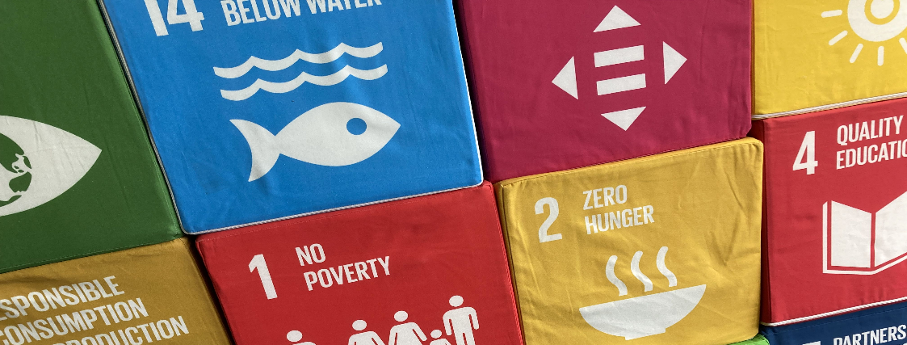
Application
Project fund
qualification N

Important information on the project fund:

- The project fund is only available for practical projects as part of qualification N. At least one member of the project team must be a participant in qualification N and want the project to be recognised as a practical project of qualification N.
- Before applying for funding from the project fund, the project idea submission form must be submitted. A preliminary discussion with Barbara Ette about the project idea is a prerequisite for this.
- The application for funding from the qualification N project fund must be submitted before the start of the project. Only costs agreed in advance can be covered or reimbursed.
- Only costs that have actually been incurred and can be documented in the form of original receipts or invoices can be covered or reimbursed.
- After consultation, invoices can also be issued directly to the Staff Unit Sustainability and thus paid without any advance payment on your part.
- Only material costs and no personnel costs can be covered. External fees are considered material costs.

Name of the project as part of the qualification N

[text]

Realisation period of the project

[text]

Applicant

Name
Surname
E-mail
Study programme
Matriculation number
Start of qualification N (semester)

(add further team members if required)

Cost plan
Please briefly describe here how much money you want to apply for/spend on what exactly. (Depending on your project, e.g. 30 euros for printing flyers; 20 euros for travel costs; 80 euros for room hire; etc.). It is often possible to obtain cost estimates in advance so that you can better estimate the costs.

Cost point | Planned expenditure
SUM

Necessity of the costs
Please briefly explain the necessity of the costs. Are the expenses unavoidable for the realisation of the project? Is the expenditure in a good cost-benefit ratio to the project objectives? What alternatives might there be?

[text]

Consideration of sustainability aspects
Are the planned purchases/materials/services/etc. for which the money is to be spent sustainable? Is the consumption of resources proportionate and justifiable in relation to the hoped-for impact? What sustainable alternatives are there to the planned purchases/materials/services/etc.?

[text]

Account data

Account holder
IBAN
BIC

If you have any questions or need support, please contact Barbara Ette:

Barbara Ette
Coordinator for teaching in the area of sustainability
Staff Unit Sustainability
07531 88 4243
barbara.ette@uni-konstanz.de

